**Aliens of America Dashboard Contest**

**Introduction**

A portfolio building dataset provided by [Ian K.](https://www.linkedin.com/in/ian-klosowicz/) on LinkedIn

## Problem Statement

For this project, you play a role as a newly hired Data Analyst for a pharmaceutical company.

It's the year 2022 and aliens are well known to be living amongst us.

Unfortunately, some of the aliens are a bit... too alien... and would like to fit into society a bit more.

So it's up to you to find the best state(s) we should market our new prescription.

It would be helpful to know...

* If these aliens are hostile
* Their diet
* Their age
* It's up to you to clean up the data and report back.

## Datasets used

This dataset contains only three tables named

* aliens
* details
* location

## Dashboard

## Entity Relationship Diagram

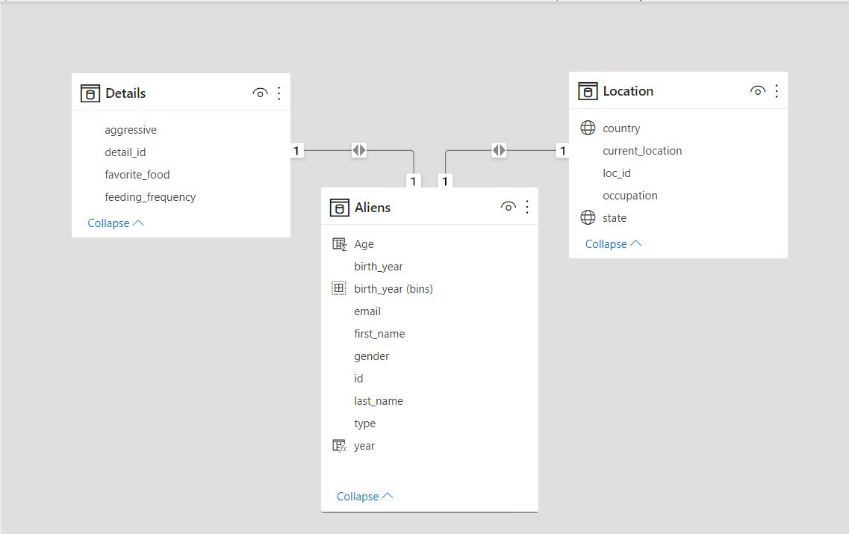

## Insights

My PowerBi dashboard submission is based on the Aliens in America dataset contest by [Ian K.](https://www.linkedin.com/in/ACoAADabnt4BCGJzRxiQW_-qytWaZvX3CXv53Io)  
  
First, I created a data model to create relationships among the tables.  
  
I have used the power query editor to transform and shape the data.  
Created various measures such as age, gender, average age, count of aliens, and gender % for data analysis and reporting.  
  
The switch function has been used to break down the centuries so that we can easily identify how many aliens were born in every century.  
  
In this report, I have tried to find below insights-  
  
# all the possible BAN( big ass numbers) ,  
# average age of aliens  
# top 5 aggressive aliens city  
# gender % ( female aliens are most)  
# trend analysis to find the feeding frequency  
# line chart to compare alien's aggressiveness with feeding frequency  
# most aliens were born between 1800-1900(16.79K)  
# the oldest alien is 350 years and the smallest age is 50  
# almost 50% of aliens are aggressive  
# 195 kind of occupations  
  
Based on this dataset I am able to find some other insights such as  
  
# which occupation do aliens like most  
# types of aliens  
  
State, feeding frequency, and types of slicers allow users to refine the data for themselves easily.  
  
Finally, I would like to give big thanks to [Ian K.](https://www.linkedin.com/in/ACoAADabnt4BCGJzRxiQW_-qytWaZvX3CXv53Io) for hosting this kind of contest where we are able to find some interesting insights about aliens and add more skills to advance our careers.  
  
I would greatly appreciate it if you kindly give some feedback.